The Role of Supply Chain Management in a Car Dealership
Operational Effectiveness, Profitability, and Strategic Advantage
A Technical Overview of Automotive Dealership Supply Chain Operations

Edward Vickers
Independent Researcher and Technical Professional
March 3, 2026

EXECUTIVE SUMMARY
Supply chain management (SCM) is a central operational function in modern automobile dealerships. While dealerships are commonly perceived as retail sales organizations, they also operate as logistics hubs that connect global automotive manufacturing with local vehicle owners. Effective SCM allows dealerships to manage vehicle allocation, parts inventory, service operations, and financial risks such as floorplan financing.
This paper introduces the structure of dealership supply chains and explains the operational responsibilities involved in managing vehicle inventory, service parts logistics, and supplier relationships. It also examines common performance metrics such as inventory turnover, fill rate, and gross margin return on inventory investment (GMROII). Particular attention is given to the “long tail” nature of automotive parts demand, where a small percentage of parts account for the majority of service demand.
Understanding dealership supply chains provides valuable insight for students studying supply chain management and for professionals considering careers in dealership operations. Dealerships function as downstream nodes in a much larger automotive supply network, and effective supply chain management directly influences profitability, customer satisfaction, and operational efficiency.

Abstract
Supply chain management (SCM) plays a vital role in the success of a car dealership. Car dealerships are more than a retail operation. Car dealerships are complex distribution hubs that coordinate vehicle sourcing, parts logistics, service operations, financing flows, and information systems. A student studying SCM and considering a career in dealership operations must understand these supply chain dynamics. This paper examines the structure of dealership supply chains, key operational challenges, performance metrics, and strategic implications, while contrasting dealership SCM with long-life military contracting and fast-cycle manufacturing environments.
The word logistics will appear regularly in this paper. The English Oxford Dictionary defines logistics as “the detailed coordination of a complex operation involving many people, facilities, or supplies.” Students of military history encounter logistics in a military context (commonly noted that armies with the best logistics usually win) but logistics applies to all operations in any field.

1. Introduction and Scope
In simplest terms, one could describe SCM as “getting all the parts and supplies that a business needs delivered to where they are needed in a timely manner without losing or misplacing any of them.” A more precise definition would be “supply chain management (SCM) is the coordination of material, information, and financial flows across suppliers, manufacturers, distributors, and customers.” This is a simple idea, but as one drills into this topic many important processes become apparent including ordering, invoicing, shipping, receiving, storing, tracking, and using. This paper can only gloss over these functions at the highest level. This paper’s intent is to provide the reader with information and tools that the reader can apply to become both a student of SCM and an expert practitioner of SCM.
A modern car dealership operation includes retail, logistics, service operations, and finance. Unlike a traditional retailer that sources products from multiple wholesalers, a dealership typically operates within a manufacturer-controlled distribution system. This manufacturer-controlled distribution system does not reduce dealership risk but requires the dealership to apply greater controls. The dealership must manage inventory risk, demand variability, service parts logistics, and supplier coordination in ways that are highly supply-chain intensive, while managing the constraints placed on the dealership by the manufacturer. While the manufacturer’s constraints increase the SCM work of the dealership, the constraints help the dealership operations by reducing complexity. A Ford dealership is unlikely to need Toyota parts. The Ford dealership only needs to manage Ford parts.
There are some dealerships that work with multiple car manufacturers. Consider the national chains CarMax, Carvana, and AutoNation along with Auto Gallery Automotive Group, a regional chain based in Georgia. These dealerships focus on used cars from any manufacturer. These dealerships must manage multiple manufacturers’ parts and handle repairs for more car makes. Their operations can be more complex than a dealership representing only a single manufacturer.
From an SCM perspective, a dealership consists of these functions:
- A downstream distribution node in the automotive manufacturer’s network.
- A service parts fulfillment center (for the dealership operations and for customers purchasing parts).
- A reverse logistics processor (warranties and returns).
- A local demand-sensing organization.
Understanding these roles clarifies how supply chain principles directly affect dealership profitability and customer satisfaction.

2. Vehicle Supply Chain Structure
Most dealerships operate under franchise agreements with manufacturers such as Ford Motor Company, Toyota Motor Corporation, or General Motors. Vehicles typically flow from assembly plants through rail or port processing centers, and then to dealerships via rail and truck transport.
Dealership SCM includes the responsibilities:
- Inventory allocation management (working within manufacturer allocation systems).
- Order configuration decisions (selecting trim, color, packages).
- Forecasting local demand.
- Floorplan financing management (inventory funded via short-term loans).
Unlike military programs that require parts availability for decades, dealerships manage high-value finished goods with rapid turnover expectations. Excess inventory increases floorplan interest costs, while insufficient inventory leads to lost sales.
Key SCM trade-offs include:
- Breadth of model offerings vs. carrying cost.
- Custom ordering vs. stock availability.
- Manufacturer push vs. dealer pull systems.

3. Parts and Service Supply Chain
The service department is often more profitable than vehicle sales. It depends heavily on effective parts management.
The dealership parts supply chain includes:
- Manufacturer regional parts distribution centers.
- Tier-1 and Tier-2 suppliers.
- Aftermarket suppliers (common for older vehicles).
- Local redistribution networks.
Tier-1 suppliers are primary partners that deliver finished components, systems, or services directly to an Original Equipment Manufacturer (OEM). Tier-1 suppliers will have long-term contract relationships with manufacturers. Bosch would be an example of a Tier-1 supplier.
Extending this relationship from Tier 1 to Tier 3, the supply chain stack becomes:
OEM
Tier-1 (system suppliers)
Tier-2 (component suppliers)
Tier-3 (raw materials)
A specific example using Ford and Bosch would be as shown below.
Ford (car and components OEM)
Bosch (Tier-1, ABS systems, spark plugs, and more)
Semiconductor manufacturer (Tier-2)
Silicon wafer producer (Tier-3)
A dealership has Tier-1 suppliers and some Tier-2 suppliers. A dealership would not manage Tier-3 providers, but events occurring between Tier-2 and Tier-3 providers can impact dealership SCM.

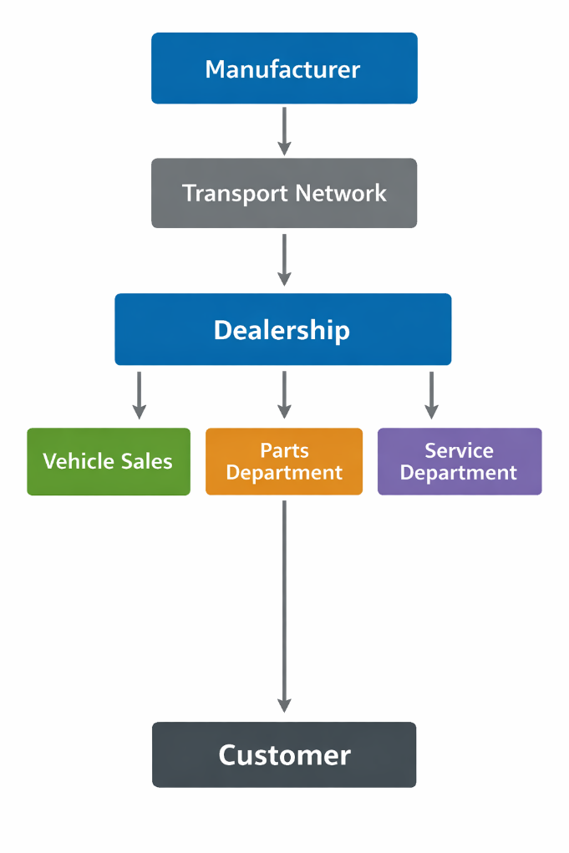
Figure 1: SCM from Manufacturer to Customer

Dealership parts managers must balance:
- Service level targets (fill rate, same-day repair).
- Inventory carrying costs (non-zero, often including tax issues).
- Obsolescence risk.
- Warranty claim processing.
Unlike electronics manufacturing environments, where component obsolescence can occur within 2–5 years, automotive service parts require availability for much longer periods, often 10–15 years or more. This resembles aspects of military logistics, though at smaller scale and with stronger manufacturer support. The “long tail” can extend farther due to vehicles remaining in service over twenty years. Dealerships may need to determine their own cutoff if the cost for stocking older parts becomes greater than revenue (or goodwill) gained by supporting older vehicles.
The “long tail” refers to the large number of products that sell in small quantities. An example of the long tail would be the large number of oil filters carried by AutoZone. A smaller number of oil filters sell in large numbers for multiple vehicles, while the remainder of the products sell in small quantities for many vehicles.
The “long tail” comes analytically from power-law demand distributions. Considering automotive parts, dealerships observe the following relationship.
20% of parts produce 80% of demand.
80% of parts produce 20% of demand.
Observers call this relationship the Pareto principle (or the 80:20 rule). Management consultant Joseph M. Juran first developed this concept in quality control after reading the works of Italian sociologist and economist Vilfredo Pareto. Sales describes this relationship as
20% of your customers give you 80% of your sales.
Even more pessimistically, some state that:
20% of your customers give you 80% of your problems.
Power laws do not describe all relationships, but automotive parts are known to follow a power-law demand distribution. Dealerships need to maximize inventory for the 20% of parts that cover 80% of demand, while strategically selecting the 80% of parts that produce 20% of demand.

Advanced dealerships use dealer management systems to track these important data items:
- Demand history.
- Economic order quantities.
- Safety stock.
- Turn rates.
- Lost sales.
Successful SCM comes from knowledge, which comes from data. A dealership cannot manage what it does not know and what it cannot measure. Effective parts SCM reduces vehicle downtime, increases customer retention, and improves technician productivity.

4. Information Flow and Technology Integration
Modern SCM is highly information-driven. SCM tools integrate these functions:
- Manufacturer ordering portals.
- Dealer management systems.
- Inventory analytics tools.
- Warranty processing systems.
- Customer Relationship Management (CRM) platforms.
Accurate forecasting relies on real-time data, seasonal patterns, recall campaigns, and marketing promotions. Modern IT tools increase the dealership’s ability to manage and track in-bound supplies and out-bound supplies. Again, this comes down to data. Data must be known, must be collected, must be stored, and must be accurate.
In this respect, dealership SCM shares similarities with engineering-driven supply chains in manufacturing and IT infrastructure, where configuration control, lifecycle tracking, and vendor coordination are essential.

5. Risk Management and Supply Disruptions
Recent global semiconductor shortages highlighted the vulnerability of automotive supply chains. Manufacturers such as Ford Motor Company and Toyota Motor Corporation reduced production, which directly constrained dealership inventory.
For dealerships, supply risk manifests as these categories:
- Reduced vehicle allocation.
- Parts backorders.
- Extended customer wait times.
- Pricing volatility.
Effective dealership SCM involves:
- Diversifying aftermarket parts sources.
- Proactive communication with customers.
- Strategic used vehicle sourcing.
- Cash flow management during allocation shortages.
Dealerships must adapt quickly to manufacturer constraints with limited design influence.
An example of how SCM affects the dealership bottom line involves vehicle sales forecasting. If a dealership forecasts a strong demand for trucks in the winter, the dealership may intentionally increase truck inventory. The dealership would also increase parts inventory to support repair and maintenance of trucks. However, if financing becomes difficult (interest rates spike) or if support costs increase (fuel prices spike), the truck demand could fall quickly. The dealership would have excess inventory, both vehicles and parts. The excess inventory would increase floorplan costs and might force the dealership to discount truck sales. The increase in unneeded repair parts would interfere with the stocking of needed parts. It is not possible to predict all events, but SCM analysis must cover risk assessment, including the case for what action to take if the dealership makes inaccurate forecasts.

6. Financial Implications of SCM
Supply chain performance directly impacts dealership profitability:
- Inventory Turnover Ratio: Higher turns reduce interest expense.
- Gross Margin Return on Inventory Investment (GMROII).
- Fill Rate in Service Parts.
- Days-to-Sell Metrics.
Dealerships finance vehicle inventory through “floorplan” arrangements. Poor inventory management can quickly erode margins due to interest costs.
Additionally, used vehicle acquisition has become a supply chain function, requiring:
- Auction sourcing.
- Trade-in valuation analytics.
- Reconditioning pipeline management.
Used vehicle management can become a difficult process to manage. With vehicles remaining in service for over twenty years, the source of parts may aftermarket manufacturers (unlikely to have contractual obligations) or junk yards (random luck required to find parts).

7. Strategic Implications for Ownership or Career
For someone studying SCM and considering dealership ownership, key competencies include:
- Demand forecasting.
- Inventory optimization.
- Vendor negotiation.
- Information systems integration.
- Working capital management.
For someone seeking employment in dealership SCM, potential roles include:
- Inventory manager.
- Parts manager.
- Fixed operations manager.
- Supply chain analyst (in larger dealer groups).
Understanding upstream manufacturing constraints and downstream retail behavior provides strategic advantage.

8. Conclusion
Supply chain management (SCM) is foundational to dealership success. Though perceived as a sales-driven retail environment, a dealership operates as a sophisticated logistics and financial coordination hub. The ability to manage vehicle allocation, parts fulfillment, risk exposure, and capital efficiently determines competitiveness.
For students of SCM, dealership operations provide a practical and dynamic application of SCM theory. This theory and practice bridge long-lifecycle support principles found in defense logistics with fast-moving, customer-driven retail realities.
A dealership is more than a showroom; it is a critical supply chain node linking automotive manufacturing with local transportation needs.
A detailed reference list and annotated bibliography follow. Note that some of these references are freely available online, but several books are expensive. We recommend that a student borrow these references from a library. Only purchase books determined to be long-term reference books.

References
Christopher, M. (2016). Logistics & Supply Chain Management (5th ed.). Pearson.
Amazon link
Heizer, J., Render, B., & Munson, C. (2020). Operations Management: Sustainability and Supply Chain Management (13th ed.). Pearson.
Amazon link
Simchi-Levi, D., Kaminsky, P., & Simchi-Levi, E. (2008). Designing and Managing the Supply Chain (3rd ed.). McGraw-Hill.
Amazon link
U.S. National Automobile Dealers Association (NADA). (2023). NADA Data: Annual Financial Profile of America’s Franchised New-Car Dealerships.
NADA industry data link
Waller, M. A., & Fawcett, S. E. (2013). “Data science, predictive analytics, and big data: A revolution that will transform supply chain design and management.” Journal of Business Logistics, 34(2), 77–84.
Wiley Online Library link

Annotated Bibliography
References Closest to Dealership SCM
- Automotive Demand Chain and Supply Chain Technologies: A Complete Guide,
This book focuses specifically on automotive demand and supply technologies, offering insights into how supply chains are structured and are managed in the automotive world, including distribution and fulfillment systems. The book coverage is more practical than academic and can help bridge SCM theory with how vehicles and parts move through an automotive network. Amazon link
G. Blokdyk, Automotive Demand Chain and Supply Chain Technologies A Complete Guide (2022), 5STARCooks

Dealership-Focused Business Books That Include SCM Elements
Few books isolate SCM from dealership operations, but several books on running dealerships touch on inventory, parts, and operational management (which are core supply chain functions):
- The Art and Science of Running a Car Dealership, a practitioner-oriented book that covers inventory management, fixed operations, and how different departments work together in a dealership. Amazon link.
M. Zanan, et. al., The Art and Science of Running a Car Dealership (2019), part of the Perfect Dealership series, Independently published.
- Perfect Dealership, Car Business 101, and Definitive Guide to F&I, these books by Max Zanan combine dealership operations with strategy and modern retail practices, including inventory and parts considerations. Article link
M. Zanan, (December 20, 2023), “He Wrote the Book On It”, F&I and Showroom,
https://www.fi-magazine.com/371983/he-wrote-the-book-on-it
This article discusses the author’s five books:
  - Perfect Dealership
  - Car Business 101
  - The Art and Science of Running a Car Dealership
  - Effective Car Dealer
  - Definitive Guide To F&I

General SCM Books that Help Build Core Competence
- Inventory and Production Management in Supply Chains, a comprehensive academic text that explores inventory strategies and production planning across supply chains. Amazon link
E. A Silver, et. al., Inventory and Production Management in Supply Chains, 4th ed. (2021), CRC Press

- Operations & Supply Chain Management: Principles and Practice, a broad SCM textbook used in many college programs (covers forecasting, inventory, logistics, etc.). arxiv link (free download)
F. Petropoulos, et. al, Operations & Supply Chain Management: Principles and Practice, arxiv, 2025, rxiv:2503.05749
Although these books are not dealership-specific, these books provide frameworks students can then apply to dealership problems like parts forecasting, replenishment policies, and service parts logistics, which are central SCM responsibilities in automotive retail.

Industry Background & Context
To understand the automotive supply chain more broadly (which feeds into dealership operations), these are classic references:
- The Machine That Changed the World explores automotive production, lean systems, and how the auto industry structures its global supply networks. Amazon link.
J. P. Womack, et. al., The Machine that Changed the World (2007), Free Press
- Toyota Supply Chain Management: A Strategic Approach, not dealership-specific, but excellent for understanding world-class supply chain principles in an automotive context. Amazon link.
IYER (Author), Toyota Supply Chain Management: A Strategic Approach to the Principles of Toyota’s Renowned System 1st Ed. (2009), McGraw Hill
Also consider these references.
R. D. Austin (March 3, 1999), “Ford Motor Co.: Supply Chain Strategy, The Harvard Business Review
S. Sarkar, The Supply Chain Revolution: Innovative Sourcing and Logistics for a Fiercely Competitive World (2017), AMACOM
R. Handfield, et. al. Flow: How the Best Supply Chains Thrive (2022), Rotman-UTP Publishing
P. F. Johnson, et. al. (July 8, 2019), Walmart: Supply Chain Management”, The Harvard Business Review
These books and references help contextualize how dealerships fit into the much larger automotive ecosystem. The references provide insight into complex retail and commercial supply changes, such as Ford Motor Company and Walmart.

Suggested Readings
If the reader must pick only one book to start with, this is a suggested priority list.
- Automotive Demand Chain and Supply Chain Technologies, closest to automotive SCM (dealer feed & parts logistics)
- The Art and Science of Running a Car Dealership, a solid practitioner perspective including dealerships’ inventory/parts functions.
- Inventory and Production Management in Supply Chains, an excellent foundational SCM textbook that the student can apply to any industry.

